**BI DESKTOP**

Report Creation:

1. Initiated the ETL process.
2. Loaded data into Power BI Power Query.
3. Conducted column profiling on the entire dataset to identify inconsistencies or errors.
4. Normalized the Orders table, transitioning from a Flat Schema to a Star Schema for enhanced model performance, scalability, and storage optimization.
5. Created a fact table (Orders) and three dimension tables. Also, removed Ship Mode as it is irrelevant to our Sales dashboard.
6. Stored the original Orders table in the Staging area and disabled load.
7. Completed the ETL process.
8. Established a separate Date table using DAX to manage multiple date columns like Order Date and Ship Date, marking it as the date table.
9. Set the storage mode for our model to Direct, as there is no need for real-time updates, and data is stored on-premises.
10. Established relationships between all tables. The Date table is connected to both Order Date and Ship Date with active and inactive relationships, respectively.
11. Added location-based columns in the Customer table to correct Data Categories for better hierarchies.
12. Inserted a text box on the top left and added the title for the report.
13. Included KPI cards for all three quantifiable metrics in our fact table. Grouped the three KPI cards, formatted, and readjusted.
14. Changed the theme to the accessible park theme for ease of access.
15. Created a line chart displaying Sales Trend Over Time by year. Added an average line for relevance and included forecasting for the next year.
16. Developed a bar chart for the top 5 selling products using a Top N filter. Turned on data labels for clarity and applied Conditional Formatting for bar colors.
17. Constructed a bubble chart, illustrating probability vs. sales for the top 5 products. Added a Median line for comparison.
18. Designed a doughnut chart visualizing sales by category. Moved the legend towards the center-left for better clarity.
19. Established a new page for customer segmentation.
20. Created a shape map for the USA. Added conditional formatting to transform it into a heatmap displaying the distribution of sales across regions.
21. Added a table displaying customers by segment. Included a slicer for the category and a "clear slicer" button.
22. Switched to the mobile layout to adjust the report pages for mobile users.

**BI SERVICE**

BI Service Tools and Options:

1. Published the report to Power BI service to create a Dashboard.

Added a personal gateway (since this is a stylized project) to establish a secure route between the semantic model stored locally and Power BI Service.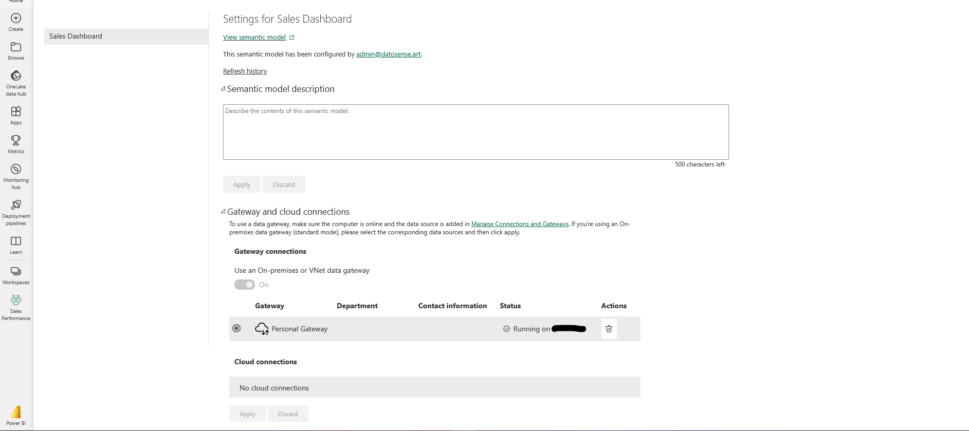

1. Applied weekly automatic refresh to our semantic model so the dashboard stays updated.

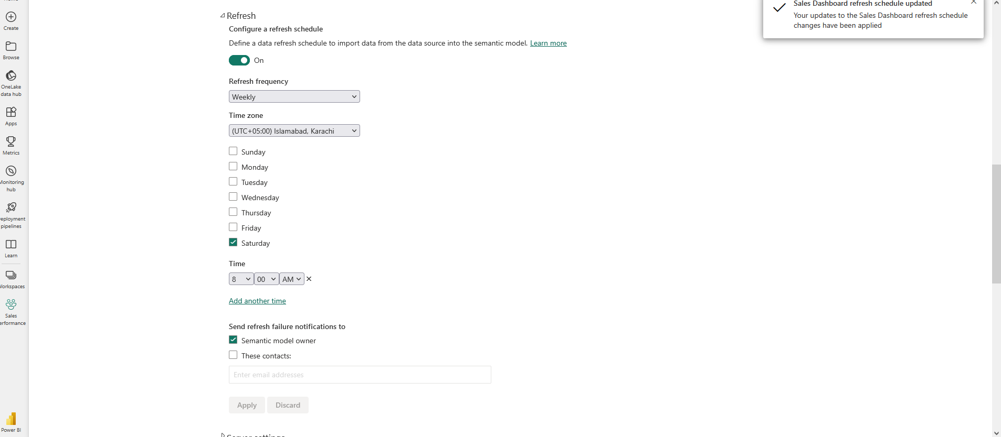

1. Promoted the dataset for better visibility, as the dataset’s integrity was verified during ETL process.

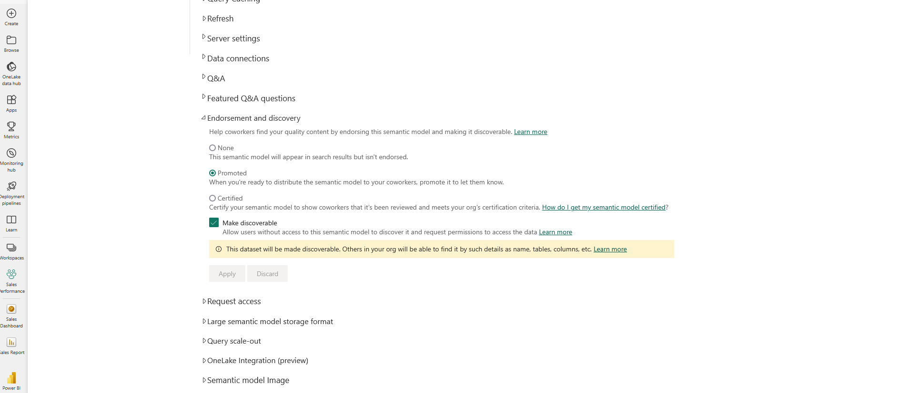

1. Turned on Query Caching since we’re using pushed data.

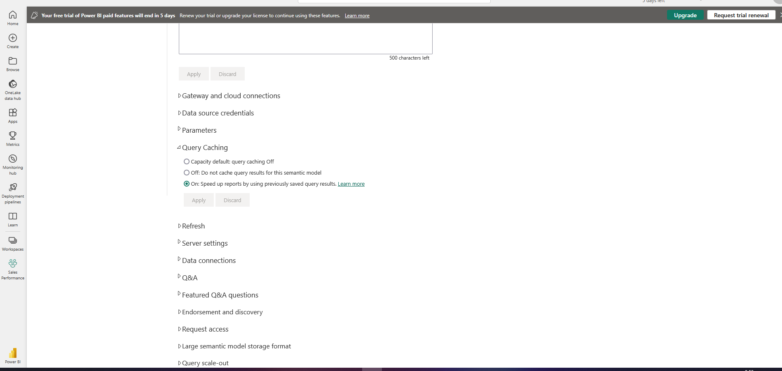

1. Checked the Q&A option in workspace settings, so the NLP Q&A tool works when using the Dashboard.

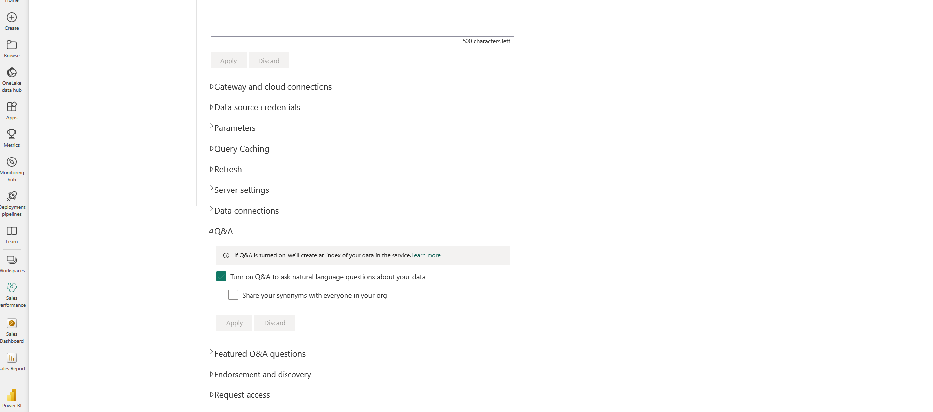

1. Inserted the data source credentials needed for security.

Dashboard Creation:

1. Pinned the entire live report to the dashboard for real-time updates instead of a static snapshot.

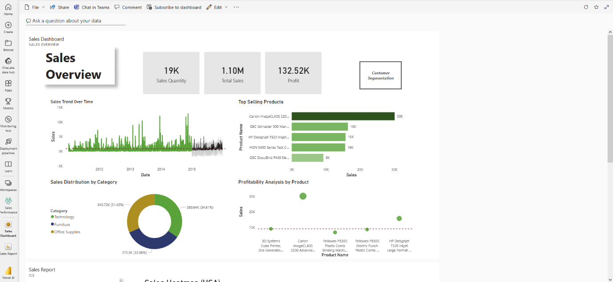

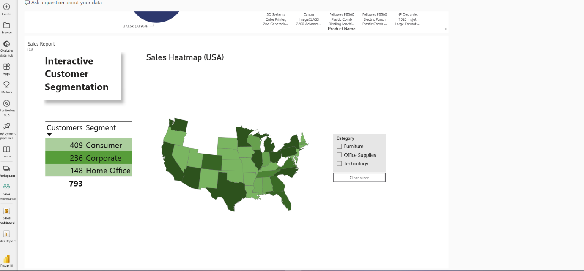

1. Added the two pinned tiles to the mobile view of the dashboard.

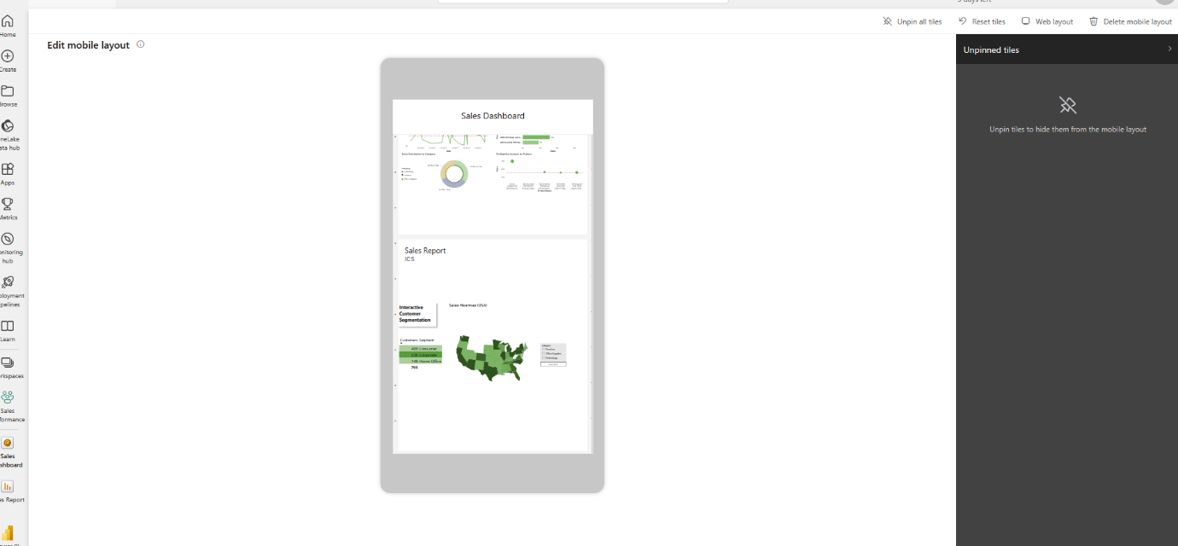

1. Added a weekly dashboard subscription as per requirements.

